Wind Speed Scatter Plot
Wright Brothers National Memorial
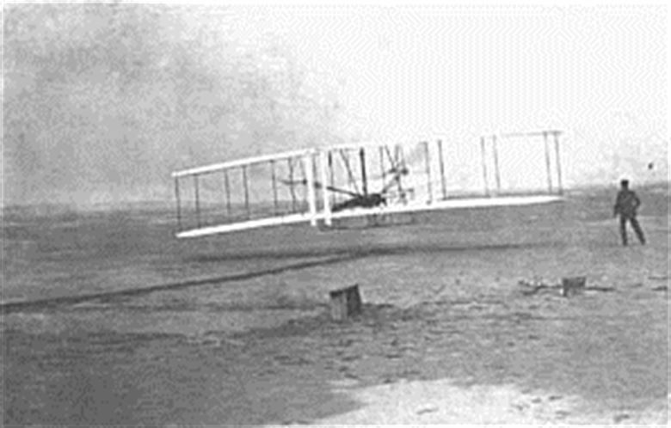
Location: On-site
Grade: 8th grade
Subject: Mathematics
Duration: 90 minutes
Key Vocabulary: anemometer, scatter plot, line of correlation, bivariate data
North Carolina State Standards:
NC.8.SP.1 Construct and interpret scatter plots for bivariate measurement data to investigate patterns of association between two quantities. Investigate and describe patterns such as clustering, outliers, positive or negative association, linear association, and nonlinear association.
Materials:
anemometer
altimeter app or device
graph paper
pencil
Site Significance:
The park is an active educational resource that offers visitors the opportunity to understand how mathematical concepts can help us gain a deeper understanding about the correlation between the natural resources at Kitty Hawk, NC and the Wright brothers achievement.

Objectives: The student will be able to: a) construct a scatter plot, b) interpret the constructed scatter plot to determine if a relationship exists, c) if a relationship exists, construct a line of correlation and determine if the relationship is positive or negative.
Essential Question: How does plotting data on a scatter plot help to determine if a relationship exists between bivariate data?
Method: Students will construct an anemometer and take wind speed measurements at various heights at Wright Brothers National Memorial. They will then plot these coordinates on a coordinate plane in order to construct a scatter plot. Finally, they will look to see if a positive or negative relationship exists between the data points.
Background: The Wright brothers chose the Kitty Hawk location for many reasons. Based upon their journal entries they had three requirements for choosing a location for their test flights: seclusion, sand, and wind. When they wrote to the Weather Bureau they wanted to gain data about wind speeds around the United States. Kitty Hawk, North Carolina provided the wind speed, isolation, and geographic terrain to give the Wright brothers the necessities to conduct their test flights.

Suggested Procedure
Pre-Visit: Prior to the Wright Brothers National Memorial visit, the teacher should lead a discussion about the features that the Wright brothers needed when choosing a location. The following website can be used to help guide this discussion. Prior to the visit, also discuss the differences between an altimeter (measuring altitude) vs. an anemometer (measuring wind speed).
https://www.loc.gov/collections/wilbur-and-orville-wright-papers/articles-and-essays/collection-highlights/kitty-hawk/
On-Site: Students will be placed in groups of 3-4. Each group will utilize the tools to build an anemometer in order to conduct their tests at various sites around the park.
Station #1 (20-30 minutes): Each group will be given the following tools: a stopwatch, 5 small cups, 3 wooden dowels, scissors, duct tape, a single hole punch, and a water bottle (more than one group can share the scissors, duct tape, and hole punch). Each group will construct an anemometer using the following steps. If a technological device is available, a video tutorial is also linked below:
Steps for Anemometer Construction:
Step 1: In 4 cups punch a single hole at the top of the cup. On the 5th cup punch 4 evenly spaced holes around the rim of the cup. Then using the scissors cut a small opening in the bottom of this cup.
Step 2: Take two of the dowels and put them through the holes of the 5th (center) cup so that they cross through the middle. Using the holes punched earlier place the remaining four cups on the ends of the wooden dowels.
Step 3: Secure each of the cups with duct tape to the dowels. Place the third wooden dowel through the bottom hole of the center cup and secure the three dowels with duct tape in the center. Also, secure the bottom dowel with duct tape to the bottom of the center cup.
Step 4: Place the center dowel into the water bottle and take to the desired location in order to gauge wind speed. Using a marker draw an “X” on one of the outer cups.
How to Calculate Wind Speed using an Anemometer:
Using a stop watch count how many rotations the anemometer makes by counting how many times the “X” passes in 30 seconds. Every spin is one mile-per-hour.
Instructional Video: https://www.youtube.com/watch?v=w65F-ZyMw-c
Station #2 (20 minutes): Each group will visit various sites around the Wright Brothers National Memorial and record the altitude of their location (using the altimeter) and the wind speed using their self-constructed anemometer. They will organize their data in a t-chart and determine whether the altitude or wind speed will represent the independent (x) and dependent (y) variable.
Station #3: (10-20 minutes): Each group will use the graph paper to create a graph and plot the points collected from their data. Students should then determine if a relationship exists between the bivariate data. If so, they will then determine if a positive or negative relationship exists.
Post-Visit:
After the visit, students should compare their data in order to determine the validity of their findings. As a group, the teacher should lead a discussion about if their findings substantiate the Weather Bureau’s records for wind speed at Kitty Hawk, North Carolina in 1903.

Evaluation Rubric:
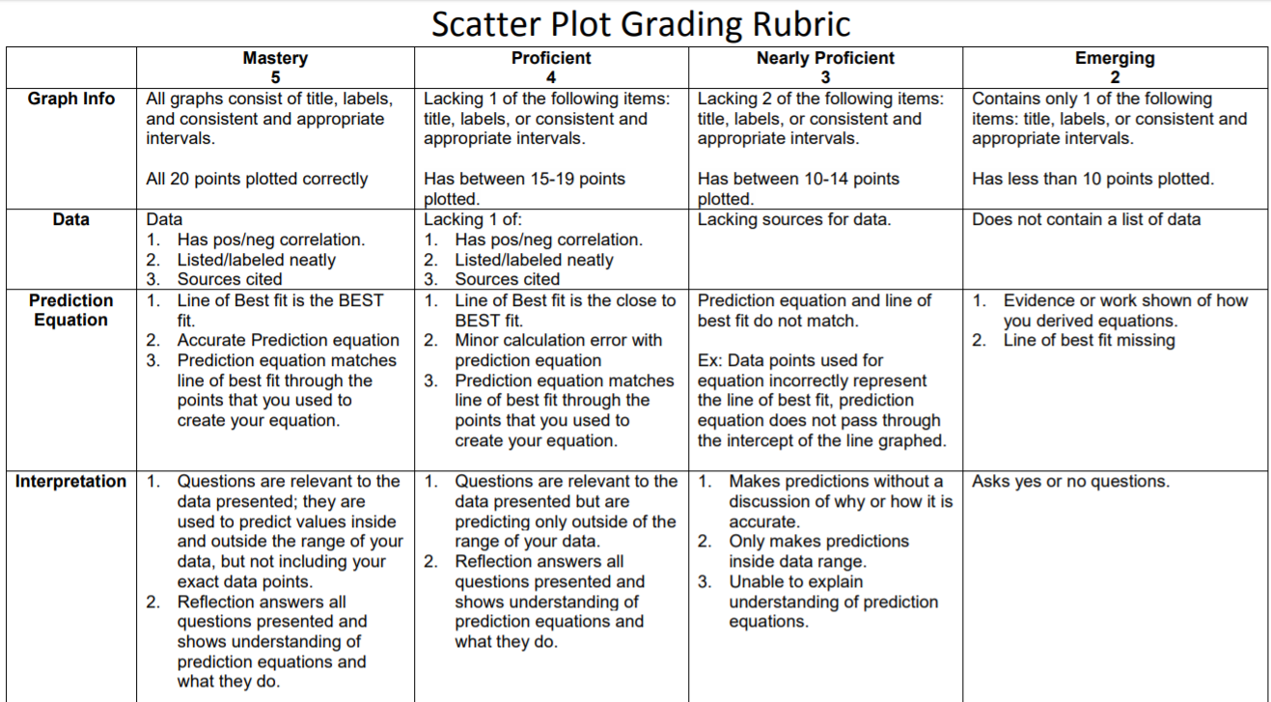

Concluding Questions:
- Why do you think that the Wright brothers chose to start their flight from ground level and not on top of Kill Devil Hill?
- What advantages did the wind speed give the Wright brothers in terms of lift?
- Why was it necessary to extend the wing length in order to gain adequate lift?
- Before their successful flight, Wilbur and Orville had numerous failed attempts to achieve flight. What factors, do you feel attributed to these failed attempts?

Extensions:
After data has been collected and graphed, students should plot a line of best fit on the graph and then determine the equation of the line. Using the equation of the line they should predict the wind speed at various heights.

Additional Resources
Websites:
https://www.loc.gov/collections/wilbur-and-orville-wright-papers/articles-and-essays/collection-highlights/kitty-hawk/
https://www.youtube.com/watch?v=w65F-ZyMw-c

Books:
The Wright Brothers, David McCullough

